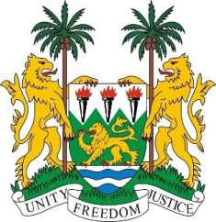
SIERRA LEONE
23rd Session of the UPR

RWANDA

4 November 2015

Mr President,

Sierra Leone warmly welcomes the delegation of Rwanda and thanks them for their presentation.

My delegation applauds the positive engagement demonstrated by Rwanda in this UPR process and their commitment to the promotion of human rights as evidenced by the timely submission of all their reports to the relevant treaty bodies, as well as their open invitation to all UN Special Procedures. Sierra Leone is particularly impressed by the exemplary high percentage of women in decision-making.

My delegation also believes that Rwanda is serving as a good example of post-conflict recovery and development.

Sierra Leone takes positive note of the important steps which the Government has taken; by implementing the Justice for Children Policy and Strategic Plan, and the National Legal Aid Policy.

Nevertheless, Rwanda is encouraged to ensure that human rights defenders are fully protected. Further strategies should be implemented to eliminate gender stereotypes which limit women’s full participation at all levels of society.

Recommendations:

- Ratify the ICPPED.
- Implement effective strategies which address child trafficking and thoroughly investigate all cases of disappearances of child refugees.
- Ensure the full application of the law in order to prevent child, early and forced marriage and to bring perpetrators of sexual violence perpetuated against children to justice.

Finally, Sierra Leone wishes Rwanda every success in completing its review.

Thank you, Mr President.

